AZAD HIND FOUZ SMRITI MAHAVIDYALAYA

DOMJUR, HOWRAH
[CO- ED. DEGREE COLLEGE]

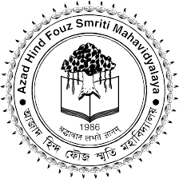

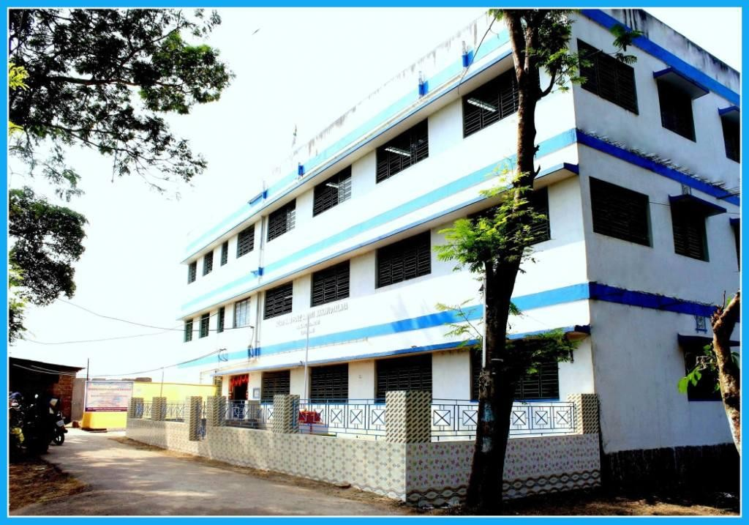

~ PROSPECTUS ~
2019-20

From the desk of the Principal
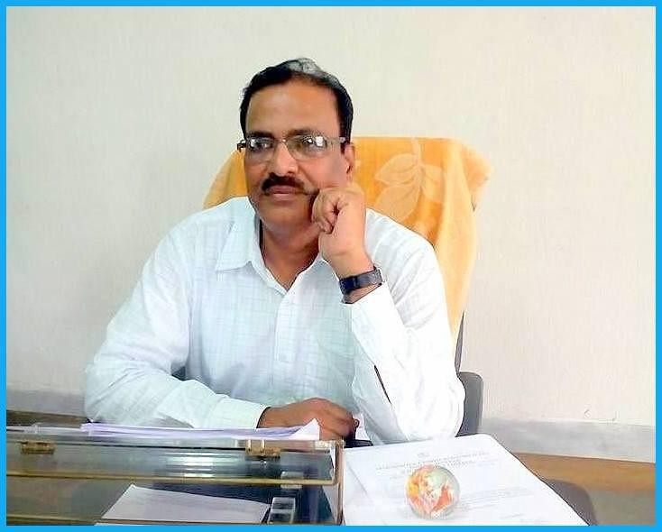

Education is the key to create a society, which is dynamic and productive, offering opportunity and fairness to all. It is one of the most essential indications of human development, the importance of which cannot be undermined. It unlocks the treasure that lies within all of us. In the coming times, knowledge and skills will be the keys to success.

The academic atmosphere of our college is healthy and free. We believe in giving our students strong values along with a set of wings which may carry them far and wide. Our students are equipped to face the challenges of the rapidly changing world. The strength of our college is the students from rural areas, minorities and economically backward class. But we strive to create an environment where each and every student is given the attention necessary to achieve his/her individual success.

Besides the usual procedural teaching, we persistently upgrade and update our teaching tools and techniques. From interactive teaching methods to a teacher- student relationship, we work around making studies as effortless as possible. Now with the financial support from the Higher Education department of West Bengal Government we are able to start virtual classroom which will help our teacher to exchange teaching quality with various part of the country as well as abroad.

Our mission is „Shraddhavan labhate gnanam’ i.e. „One who has faith attains knowledge‟

DR. ASIM KUMAR GHOSH

PRINCIPAL

1. INTRODUCTION

A SHORT HISTORY OF THE COLLEGE

Azad Hind Fouz Smriti Mahavidyalaya, affiliated to the University of Calcutta, started its journey on 8th October 1986. Its location is ideal for an educational institution. It is far enough from the hub of overpopulated areas and yet easily accessible by bus and rail. As the College is located beside the Howrah
– Amta Road, the facility of regular bus service can be availed of to reach the College. Hence students from the adjoining region of the Howrah district as well as from the neighbouring Hooghly and even Midnapore, come here for higher education.

At present the College imparts Honours Courses in English, Bengali, Geography, History and Education and General Courses in English, Bengali, Sanskrit, Education, Philosophy, Geography, Economics, Mathematics, History, Political Science and B.Com. The College is committed to provide quality education at the undergraduate level to students irrespective of caste, creed, religious and gender. The mission of the College is to enable the students to live fruitful lives and make meaningful contributions to the community.

The mission of the college is to enable the students to live fruitful lives and make meaningful contributions to the community. The vision of our college is to reach out to the vast hinterland and rejuvenate the young minds with the message enshrined in the Rig Veda – śraddhāvān labhate jñānam – “The reverent attains wisdom.” This is in itself is a difficult task as it requires the active co-operation of all the stakeholders – the students, teachers and the non-teaching staff, and the community at large – and their commitment to maintain an atmosphere of academic integrity within the campus, and at the same time, be conscious of their social responsibility, outside the boundary of the institution.

From a humble beginning the College has made a slow but steady progress. The College is aware of the necessity to get itself assessed by the expert team of National Assessment and Accreditation Council (NAAC), an autonomous institution under the University Grants Commission. For us NAAC is a guardian of quality in Higher Education and its assessment provides the occasion to assess our own strengths and weaknesses and also gives us a guideline for the future growth of the institution. The college has entered the accreditation process and hopes to get itself evaluated in the near future.

The management of the College, under the present set up is vested in the Principal who in consultation with and on the advice of the Governing Body administers the institution. The present Governing Body is formed as per provisions of Clause 93 of the Calcutta University First Statutes, 1979 and its subsequent amendments. As the apex body it regulates all endeavours of the College.

THE GOVERNING BODY

- Justice Md. Abdul Ghani President
- Dr. Asim Kumar Ghosh Principal & Secretary
- Sri Sourav Chattopadhyay Government Nominee
- Sri Mrityunjoy Chakraborty Government Nominee

- Sri Prabhat Kumar Karar Nominee of WB State Council of Higher Education
- Prof. Sarada Mandal Calcutta University Nominee
- Dr. Satya Prakash Tiwari Calcutta University Nominee
- Sri Partha Pratim Mukherjee Teachers‟ Representative
- Dr. Mrinal Kanti Mondal Teachers‟ Representative
- Dr. Nityananda Mandal Teachers‟ Representative
- Sri Asish Kumar Paul Non-teaching Employees‟ Representative

The College is dedicated to the principle of decentralisation and works on the basis of Committee system. As per the guidelines of the University of Calcutta, various Sub-Committees are formed with their authority and mutual responsibility relationships clearly defined.

2. COURSE CURRICULA

COURSES OF STUDY
The College offers full-time Three-year (six semesters) Degree Programmes of the University of Calcutta in Bachelor of Arts and Bachelor of Commerce. It is also to be noted that from the previous academic session (2018-19) Semester wise Three year B.A. (Honours and General) courses of studies under Choice Based Credit System (CBCS) has been introduced. The same system in Commerce stream is already in vogue from the last session i.e. 2017-18.

DURATION OF THE PROGRAMME

The 3 year B.A. / B.Sc. /B.Mus. (Honours/General) Programme shall be for a minimum duration of six
(6) consecutive semesters of six (6) months each, i.e., three (3) years. The odd semester will start ordinarily in the month of July and the even semester in the month of January of every year.

A candidate pursuing a regular course of study for three-year semester-wise degree course shall have to clear all the semesters in all respects within a span of five years from the year of admission to the particular course and combination, failing which enrolment of the candidate shall stand cancelled.

ARTS

1. English | Honours | and | General
2. Bengali | Honours | and | General
3. History | Honours | and | General
4. Education | Honours | and | General
5. Geography | Honours | and | General
6. Political Science | General
7. Sanskrit | General
8. Philosophy | General
9. Economics | General
10. Mathematics | General
COMMERCE  1. B. Com. | General

OUTLINE OF CHOICE BASED CREDIT SYSTEM

- Core Course (CC): A course which should compulsorily be studied by a candidate as a core requirement is termed as a Core Course.

Students taking up Honours programme in any subject shall have to study 14 Core Courses of the Honours Subject as specified for each of the 6 semesters .

Students taking up General programme shall have to study 4 Core Courses of each of the 2 chosen subjects as specified for each of the first 4 semesters. In addition 4 Core Courses to be studied; 2 courses each from 2 language subjects: Language Core Course (LCC) – 1 (English) and LCC – 2 (Bengali) as specified for each of the last 4 semesters.

- Elective Course: Generally a course which can be chosen from a pool of courses and which may be very specific or specialized or advanced or supportive to the discipline/subject of study or which provides an extended scope or which enables an exposure to some other discipline/subject/domain or nurtures the student‟s proficiency/skill is called an Elective Course.

  - Discipline Specific Elective (DSE) Course: Elective courses which may be offered by the main discipline/subject of study is referred to as Discipline Specific Elective. This course is to advance knowledge and skill in the core course domain.

Students taking up Honours programme in any subject shall have to study 4 Discipline Specific Elective (DSE) courses strictly on the Honours subject. Such a student shall have to study the curriculum of DSE on the Honours subject concerned as specified for the relevant semester.
(Explanation: Each Honours subject shall have two groups (A & B) of DSE papers. A student shall choose any one paper from each of Group A and Group B in 5th semester and 6th semester.)

Students taking up General programme shall have to study 4 DSE courses strictly on 2 subjects, opted for pursuing Core Courses, taking exactly 2 courses from each subject. Such a student shall have to study the curriculum of DSE of the subject concerned as specified for the relevant semester, i.e., DSE-A in the 5th and DSE-B in 6th semester.
(Explanation: Each General subject shall have two groups (A and B) of DSE papers. A student shall have to choose one paper from Group A of each of the two subjects in the 5th semester and one paper from Group B of each of the two subjects in the 6th semester.)

  - Generic Elective (GE) Course: An elective course chosen generally from an unrelated discipline/subject, with an intention to seek wide exposure, is called Generic Elective.

Students taking up Honours programme shall have to choose 4 Generic Elective papers strictly from 2 subjects of choice taking exactly two courses from each subject as specified for first 4 semesters.

Students taking up General programme shall have to choose 2 Generic Elective papers strictly from one particular subject [which will be different from the core subjects including the Core Languages (LCC1 and LCC2)] as specified for the 1st and 2nd semester.

N.B.: A core course offered in a discipline/subject may be treated as an elective by other discipline/subject and such electives may also be referred as Generic Elective. [A Core Course (CC) of B. A. General may be treated as Generic Elective for B.A. (Honours) and B.A. (General)].

- Ability Enhancement Courses (AEC): The Ability Enhancement Courses (AEC) may be of two kinds: Ability Enhancement Compulsory Courses (AECC) and Skill Enhancement Courses (SEC).

Ability Enhancement Compulsory Courses (AECC): AECC courses are the courses based upon the content that leads to knowledge enhancement. These are mandatory for all disciplines.

AECC1: Communicative English/Bengali and AECC2: Environmental Studies.

Skill Enhancement Courses (SEC): These courses may be chosen from a pool of courses designed to provide value-based and/or skill based knowledge and are aimed at providing competencies, skills, etc.

Students taking up Honours programme shall have to study 2 skill enhancement courses strictly on the Honours subjects. Such a student shall have to study the curriculum of SEC on the Honours subjects concerned as specified for the relevant semester, i.e., SEC-A in the 3rd semester and SEC-B in the 4th semester.
(Explanation: Each Honours subject shall have two groups (A and B) of Skill Enhancing Course papers. An Honours student shall have to choose one paper from Group A in 3rd semester and one paper from Group B in 4th semester.)

Students taking up General programme shall have to study 4 Skill Enhancement courses strictly on two subjects, opted for pursuing Core Courses, taking exactly 2 courses from each subject. Such a student shall have to study the curriculum of SEC of the subject concerned as specified for the relevant semester. (Explanation: Each General subject shall have two groups (A and B) of SEC papers. A student shall have to choose one paper from Group A of each of the two core subjects in the 3rd and the 5th semesters and one paper from Group B of each of the two core subjects in the 4th and the 6th semesters.)

Every Core, Discipline Specific and Generic Elective Course shall have a Practical/Tutorial component. Wherever there is a Practical, there will be no Tutorial and vice-versa.

A detailed outline of the available combination of subjects is given below: -

HONOURS SUBJECTS:

Sl  No | Course | Core Honours Subject | Generic Elective 1 | Generic Elective 2
1 | B.A. | English | History | Philosophy
2 | B.A. | English | Education | Sanskrit
3 | B.A. | English | Education | Philosophy
4 | B.A. | Bengali | Education | History
5 | B.A. | Bengali | Education | Sanskrit
6 | B.A. | Bengali | History | Political Science
7 | B.A. | Education | History | Philosophy
8 | B.A. | Education | History | Sanskrit
9 | B.A. | Education | Philosophy | Sanskrit
10 | B.A. | History | Education | Philosophy
11 | B.A. | History | Education | Political Science
12 | B.A. | History | Philosophy | Political Science
13 | B.A. | Geography | Education | History
14 | B.A. | Geography | Education | Political Science
15 | B.A. | Geography | Economics | Education
GENERAL SUBJECTS:

Sl  No | Course | Core Subject 1 | Core Subject 2 | Generic Elective
1 | B.A. | Bengali | History | Political Science
2 | B.A. | Geography | History | Education
3 | B.A. | Education | Bengali | History
4 | B.A. | Education | English | Philosophy
5 | B.A. | Education | History | Political Science
6 | B.A. | Education | Bengali | Sanskrit
7 | B.A. | Education | Philosophy | Economics
8 | B.A. | Education | Philosophy | Sanskrit
9 | B.A. | Geography | History | Political Science
10 | B.A. | Geography | English | Education
11 | B.A. | History | Education | Philosophy
12 | B.A. | History | Political Science | Philosophy
13 | B.A. | History | Political Science | Sanskrit
14 | B.A. | History | English | Philosophy
15 | B.Com.
ADMISSION AND RELATED INFORMATION

Immediately after the publication of the results of the Higher Secondary Examination, Admission Forms will be available from the college website. All candidates, who are declared eligible as per Calcutta University norms, may apply for admission online. All information regarding admission will be notified on the College website: www.ahfsm.ac.in or http://ahfsmadmission.in

Students are admitted on the basis of merit and availability of seats.

GENERAL GUIDELINES

- Admission to Honours and General courses is on-line.
- Admission of a candidate will be cancelled if any information given by him/her is found to be wrong or suppressed.
- Admission is strictly provisional, subject to final scrutiny and acceptance by the appropriate authorities including the University of Calcutta by way of issuing Registration Certificate and Admit Card.

HONOURS COURSE | TOTAL SEATS AVAILABLE
Bengali (BNGA) | 41
Education (EDCA) | 35
English (ENGA) | 29
Geography (GEOA) | 37
History (HISA) | 35

GENERAL COURSE | TOTAL SEATS AVAILABLE
B.A. (General) | 600
B. Com. (General) | 100

A certain percentage of seats in all courses are reserved for SC, ST, OBC-A, OBC-B and Physically Handicapped candidates as per West Bengal Government rules. Candidates have to upload scanned copies of Certificates issued by competent authority for seeking admission against reserved seats.

DOCUMENTS TO BE UPLOADED FOR ADMISSION
- Photocopy of Admit Card or Certificate of Madhyamik or equivalent examination.
- Photocopy of Admit Card and Mark sheet of Higher Secondary or equivalent examination.
- A recent passport sized Photograph.
- Photocopy of Certificate from competent authority for SC, ST, OBC-A, OBC-B and Physically Handicapped candidates, if applicable.
- Photocopy of Migration Certificate for students migrating from other Boards/University.

PAYMENT OF FEES
Tuition fees are due on the first working day of each month. Payment of fees can be made on all weekdays on production of the Fee Book. Fees can be paid at the cash counter of the College Office as per the following timings:
  - Monday to Friday from 10:30 a.m. to 3.30 p.m.
  - Saturday from 10:30 a.m. to 12:30 p.m.

REFUND OF DEPOSITS
Library and Laboratory deposits are refunded after deduction, if any, to the students on production of the original payment receipt (Fee Book). This refund can be received following the publication of the results of the B.A. / B.Com. 6th and Final Semester Examination in which the student appeared. This refund can be claimed during cash hours within the next three years from the day of publication of the result. Claims of a defaulter will not be entertained afterwards under any circumstances in this regard.

TRANSFER / WITHDRAWAL / CANCELLATION OF ADMISSION/ DISCONTINUATION OF STUDIES
- A student may apply to the Principal for Transfer / Withdrawal / Cancellation of admission.

- A student seeking Transfer / Withdrawal during mid-session must pay all Annual charges, Tuition fee up to the current month and the Transfer fee. The student must obtain a Clearance Certificate beforehand from the Library.

- Incase of Cancellation of admission only Library and Laboratory deposit will be refunded. The Registration fee of the University of Calcutta will be refunded only if it is not deposited into the University account.

- A student who wants to discontinue studies or remains absent from College for a long time without applying for withdrawal of name shall be liable to clear all the College dues up to the current month, if he/she wants to collect any Certificate or record from the College at a subsequent date.

CHANGE OF SUBJECT
For any change of subject after admission, the student concerned shall have to apply to the Principal in writing within the date stipulated by the University of Calcutta.

CHANGE OF ADDRESS
The student concerned must immediately communicate any change of address to the Principal in writing.

IDENTITY CARD
At the time of admission every student will be provided with an Identity Card. Students must come to the College with their Identity Cards and must show the cards when asked to do so. If the Identity Card is lost a duplicate card may be issued on payment of requisite fees.

ATTENDANCE

Students are instructed to be very regular in attendance in the class and very sincere in their studies.

  - A student attending at least 75% of the total number of classes* held shall be allowed to appear at the concerned Semester Examinations subject to fulfillment of other conditions laid down in the regulations.

  - A student attending at least 60% but less than 75% of the total number of classes* held shall be allowed to appear at the concerned Semester Examinations subject to the payment of prescribed condonation fees and fulfillment of other conditions laid down in the regulations.

  - A student attending less than 60% of the total number of classes* held shall not be allowed to appear at the concerned Semester Examinations and he /she has to pursue admission to the same Semester in the very next year for attending the classes and appearing at the said Semester Examination.

*Such attendance will be calculated from the date of commencement of classes or the date of admission, whichever is later.

DISCIPLINE

Admission binds a student to observe rules and regulations of the College as issued by the authorities from time to time. Students must observe strict discipline in the Classroom, in the College Office, in the Library and Reading Room, in the Playground and the College campus in general as well as in all spheres of College life. They are expected to behave with modesty and dignity and to maintain proper academic atmosphere as well as necessary decorum and decency in the College.

ACADEMIC CALENDAR

The academic session of the College commences every year on the first day of July and terminates on the last day of June.

The Academic Calendar for the B.A. / B.Com. (Honours/ General) Courses of Studies (under CBCS with Semester-wise Examinations) for the Academic Session 2019-20 is as follows:

Course of Studies | Commencement of classes | Internal Assessment Exam  (By the College) | Commencement of  Examinations (Tentative) |  | Publication of Result (Tentative)
 |  |  | Practical/ Tutorial | Theoretical
Semester I | 1st Week of July, 2019 | 3rd week of November, 2019 | 4th week of November, 2019 | 2nd week of December, 2019 | Within 45 days from the last date of Exam.
Semester II | Within 7 days from the completion of 1st  Semester Exam | 3rd week of May, 2020 | 4th week of May, 2020 | 2nd week of June, 2020 | Within 45 days from the last  date of Exam.
Semester III | Within 7 days from the completion of 2nd Semester Exam | 3rd week of November, 2019 | 4th week of November, 2019 | 2nd week of December, 2019 | Within 45 days from the last date of Exam.
Semester IV | Within 7 days from the completion of 3rd Semester Exam | 3rd week of May, 2020 | 4th week of May, 2020 | 2nd week of June, 2020 | Within 45 days from the last date of Exam.
Semester V (Only for B.Com.) | Within 7 days from the completion of 4th Semester Exam | 3rd week of November, 2019 | 4th week of November, 2019 | 2nd week of December, 2019 | Within 45 days from the last date of Exam.
Semester VI (Only for B.Com.) | Within 7 days from the completion of 5th Semester Exam | 3rd week of May, 2020 | 4th week of May, 2020 | 2nd week of June, 2020 | Within 45 days from the last date of Exam.

Academic Calendar for the B.A. Courses of Studies (under 1+1+1 System of Examinations) for the Academic Session 2018-2019 is as follows:
Course of Studies | Commencement of classes | Mid-Term Exam | College Test | Result of College Test
Part III | Within 7 days  from the completion of Part-II Exam | October, 2019 | 1st week of January,  2020 | 3rd week of January, 2020

Note: The College Academic Calendar is subject to unavoidable changes.

A student must appear at all the above examinations. For absentees, on medical grounds, the production of Medical Certificate by a Registered Medical Practitioner is compulsory.

Provisional List of Holidays for the Session 2019-20

Rathajatra | 4th July | Thursday
Id-uz-Zoha | 12th August | Monday
Independence Day | 15th August | Thursday
Janmastami | 23rd August | Friday
Muharram | 10th September | Tuesday
Viswakarma Puja | 17th September | Tuesday
Mahalaya | 28th September | Saturday
Gandhiji‟s Birthday | 2nd October | Wednesday
Puja Vacation | 4th October | Friday
 | to  30th October | Wednesday
College Foundation Day | 8th October | Tuesday
Jagaddhatri Puja | 6th November | Wednesday
Fateha-Doaz-Daham | 10th November | Sunday
Guru Nanak‟s Birthday | 12th November | Tuesday
Christmas | 25th December | Wednesday
Winter Recess | 26th December | Thursday
 | to  31st December | Tuesday
New Year‟s Day | 1st January | Wednesday
Swami Vivekananda‟s Birthday | 12th January | Sunday
Netaji‟s Birthday | 23rd January | Thursday
Calcutta University Foundation Day | 24th January | Friday
Maghotsav | 25th January | Saturday
Republic Day | 26th January | Sunday
Saraswati Puja | 29th January | Wednesday
 | 30th January | Thursday
Shivaratri | 21st February | Friday
Doljatra | 9th March | Monday
Holi | 10th March | Tuesday
Good Friday | 10th April | Friday
Easter Saturday | 11th April | Saturday
Chaitra Sankranti | 13th April | Monday
Bengali New Year‟s Day | 14th April | Tuesday
May Day | 1st May | Friday
Buddha Purnima | 7th May | Thursday
Rabindra Jayanti | 9th May | Saturday
Summer Recess | 16th May | Saturday
 | to  30th June | Tuesday
Id-ul-Fitr | 23rd May | Saturday

* During the Recess only Classes will remain suspended

CO-CURRICULAR ACTIVITIES

The College encourages the students to participate in co-curricular activities for the all-round development of their personality.

CULTURAL PROGRAMMES
The Students‟ Union of the College organizes a number of cultural programmes. The Republic Day, Independence Day and Netaji’s Birthday are observed with due respect. Saraswati Puja is also organised every year. Nabin Baran (Freshers‟ Welcome) is organised to welcome the First Year students. The University Foundation Day (24th January) is celebrated every year. The College Social is organised with tremendous enthusiasm every year in February. The occasion is graced by many eminent personalities of the locality.

The College celebrated the International Mother Language Day, Basanta Utsab and Rabindra Jayanti this year.

WORKSHOPS AND AWARENESS PROGRAMMES

From time to time the College organises Workshops and Awareness Programmes on diverse subjects.

GAMES AND SPORTS
The College has an extensive playground of its own, inside the campus, which is used for Annual Sports. Prizes are given to all the successful contestants. The College students participate in the Inter-College Football Tournaments/Championships organised by the University of Calcutta. The college also organized Inter College District Sports & Games Championship, 2017-18 (Howrah District) from 3rd February, 2018 to 5th February, 2018.

COLLEGE MAGAZINE
The College Magazine called SRIJANI is published annually by the Students‟ Union. The different departments also bring out Wall-Magazines periodically.

SEMINARS AND STUDY TOURS

The Departments of Bengali and Commerce organised UGC sponsored National Seminars in the college. Eminent faculty members from different universities of West Bengal were present in the seminar.

COMPUTER COURSE

The College offers one year Diploma in Computer Application (150 hours) at a subsidized rate in collaboration with Webel Informatics Limited (A Govt. of West Bengal undertaking).

EXTENSION ACTIVITIES

The College was chosen by the Higher Education Department, Government of West Bengal, for organizing the “75 years of Netaji's Great Escape” in the district of Howrah. Participants from neighbouring colleges in the district of Howrah took part in a two-day programme of essay-writing, quiz, poster-drawing and extempore speech.

The College was chosen by the Higher Education Department, Government of West Bengal, for organizing the “Inter-College District Sports & Games Championship, 2017-18” in the district of Howrah. Participants from neighbouring colleges in the district of Howrah took part in a three-day programme of foot-ball, kho-kho and athletics championship.

NSS ACTIVITIES

The College encourages the students to participate in various extension activities. The College has two National Service Scheme (N.S.S.) units, which has taken up and successfully completed many projects. The N.S.S. units and the Students‟ Union jointly organise Blood Donation Camps, Awareness Camps, Adult Education Camps, carry out Afforestation Programmes, conduct cleaning up operations in the College premises, give First-Aid and so on. The College observes the Flag Day programme initiated by the National Council for Communal Harmony. Debate, Quiz and Poster and Essay Competitions are organised in connection with this programme.

STUDENTS‟ UNION
- STUDENTS’ AMENITIES

All the students of the College are members of the Students‟ Union whose office bearers are selected from among elected class representatives. Annual elections are held usually in the month of December, under the supervision of an Election Commission. The basic duty of the Students‟ Union is to voice the demands of the students, create and maintain a healthy academic atmosphere, organise different co- curricular and extension activities and be involved in the developmental activities of the College. The General Secretary of the Students‟ Union is the ex-officio member of the Governing Body of the College.

COLLEGE COMMON ROOMS

There are separate Common Rooms for boys and girls in the College. Students can relax and play indoor games in the Common Rooms during their off-periods.

COLLEGE GYMNASIUM, PLAYGROUND, CANTEEN AND CYCLE-STAND

The College has a well-equipped modern Multi-gym. The College has an extensive playground of its own, inside the campus. The College has its own canteen which caters to both students and staff. The

College has a spacious cycle-stand, near the main gate, where students can keep their cycles during College hours.

COLLEGE LIBRARY AND READING ROOM

The College Library has a stock of more than 10,000 books. Students can read text and reference books and periodicals in the spacious Reading Room. Daily newspapers are also available in the Library. The students may borrow books, subject to the observance of the rules and regulations of the College Library.

COLLEGE LABORATORY

The College has renovated the Geography Laboratory and now the College has a fully computerised GIS Unit. There is a separate Computer Laboratory for students of B.Com.

SCHOLARSHIP / STIPEND

Scheduled Caste and Scheduled Tribe Scholarship/Stipend are granted by the Directorate of Scheduled Castes and Scheduled Tribes Welfare, Government of West Bengal. The District Mass Education Extension Office, Howrah, grants handicapped Scholarship. The WBMDFC Talent Support is also provided by the Government of West Bengal.

FULL FREE / HALF FREE STUDENTSHIP

Meritorious students coming from poor families are granted Full Free/Half Free concession in tuition fees. Such concession is provided to approximately 10% of the students of the College.

RAILWAY AND BUS CONCESSIONS

The College permits the students to enjoy Railway Concessions of the Eastern and South-Eastern Railways. Bus Concessions are also available for the students. The Railway and Bus authorities, as per their rules and regulations, issue these concessions on the basis of recommendations made by the College authority.

STUDENTS‟ HEALTH HOME

The College is affiliated to the Students‟ Health Home scheme. Students can get medical facilities and specialised treatment against an annual subscription.

ACADEMIC AND PERSONAL COUNSELLING

The College has a Counselling Cell which offers academic/career counseling to the students. Apart from that the teachers of the college also offer informal academic and personal counselling to the students for the all-round development of their personality.

STAFF

PRINCIPAL
Dr. Asim Kumar Ghosh, M.A., Ph.D.

BURSAR
Dr. Mrinal Kanti Mondal, M.A., M.Phil., Ph.D. Assistant Professor, Department of Bengali

FACULTY

DEPARTMENT OF ENGLISH
- Dr. Aditi Sengupta, M.A. Ph.D. Assistant Professor & Head of the Department
- Sri Susanta Hati, M.A. Part Time Teacher

DEPARTMENT OF BENGALI
- Dr. Mrinal Kanti Mondal, M.A., M.Phil, Assistant Professor Ph.D.
- Dr. Nityananda Mandal, M.A., Ph.D. Assistant Professor & Head of the Department
- Smt. Gargi Chattopadhyay, M.A. Part Time Teacher

DEPARTMENT OF HISTORY
- Sri. Partha Pratim Mukherjee, M.A. Associate Professor & Head of the Department
- Smt. Mahuya De (Ghosh), M.A. Part Time Teacher
- Sri Pradipta Paul, M.A., M.Phil. Invitee Teacher
- Sri Ananta Chandra, M.A. Invitee Teacher
- Sri Koushik Ghosh, M.A. Invitee Teacher

DEPARTMENT OF POLITICAL SCIENCE
- Smt. Swapna Banerjee, M.A. Part Time Teacher
- Sri. Dipankar Sarkar, M.A. Part Time Teacher

DEPARTMENT OF EDUCATION
- Dr. Julie Dutta, M.A., B.Ed., M.Ed., Assistant Professor & Head of the Department M.Phil, Ph.D.
- Sri Patit Paul, M.A., B.Ed. Assistant Professor
- Smt. Bandana Mondal (Baidya), M.A. Part Time Teacher
- Smt. Mousumi Pramanik, M.A. Invitee Teacher

DEPARTMENT OF GEOGRAPHY
- Dr. H. M. Kutub Uddin, M.Sc., Ph.D., Assistant Professor & Head of the Department PGD on GIS & RS.

- Sri. Ritabrata Mukhopadhyay, M.Sc. Assistant Professor
- Sri. Rajkumar Ghosh, M.A. Part Time Teacher

DEPARTMENT OF SANSKRIT
- Sri Sukanta Kanrar, M.A. Invitee Teacher
- Smt. Arpita Rana, M.A. Invitee Teacher

DEPARTMENT OF PHILOSOPHY
- Smt. Sudeshna Mullick, M.A. Invitee Teacher
- Sri. Somnath Pramanik, M.A. Invitee Teacher

DEPARTMENT OF ECONOMICS 1.

DEPARTMENT OF COMMERCE
- Dr. Palash Bandyopadhyay, M.Com., Assistant Professor & Head of the Department M.Phil., Ph.D.
- Sri Somnath Mukhuti, M.Com., M. Phil. Invitee Teacher
- Sri Ujjal Mondal, M.Com., M. Phil. Invitee Teacher

OFFICE STAFF

  - Sri. Asish Kumar Paul Head Clerk
  - Sri. Pratik Ghosh Accountant
  - Sri. Manan Kumar Ghosh Cashier
  - Sri. Bidesh Modak Clerk
  - Vacant Library Clerk
  - Sri. Ram Chandra Ghosh Clerk cum Typist
  - Sri. Pradip Kumar Pan Bearer
  - Sri. Harimohan Naskar Bearer
  - Sri Sherlock Ghosal Library Peon
  - Sri. Asish Banerjee Guard
  - Smt. Gouri Mondal Lady-Attendant

7. CONTACT INFORMATION

Azad Hind Fouz Smriti Mahavidyalaya Howrah-Amta Road
Domjur, Howrah.
PIN- 711405

Tel: 033-2670-0838

Email: ahfsm.howrah@gmail.com
Website: www.ahfsm.ac.in

